AKSIPS SMART SCHOOL – UNIFORM DETAILS
WINTER UNIFORM SUMMER UNIFORM
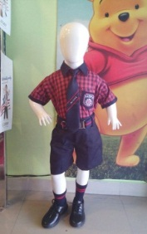
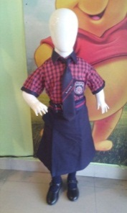
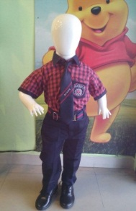
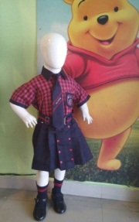
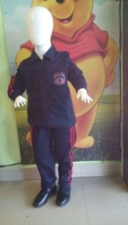
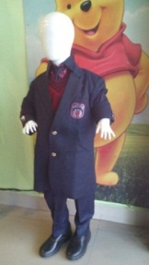
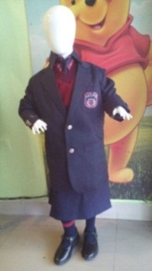

BOYS & GIRLS BOYS GIRLS BOYS GIRLS BOYS GIRLS
CLASSES PLAYWAY TO KG CLASSES I TO XII CLASSES I TO XII CLASSES PLAYWAY TO IV CLASSES PLAYWAY TO KG CLASSES V TO XII CLASSES I TO XII
(MONDAY TO SATURDAY) (ALL DAYS EXCEPT WED & SAT) (ALL DAYS EXCEPT WED & SAT) (ALL DAYS EXCEPT WED & SAT) (ALL DAYS EXCEPT WED & SAT) (ALL DAYS EXCEPT WED & SAT) (ALL DAYS EXCEPT WED & SAT)

HOUSE WISE UNIFORM FOR CLASSES I TO XII (WEDNESDAYS & SATURDAYS)
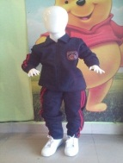
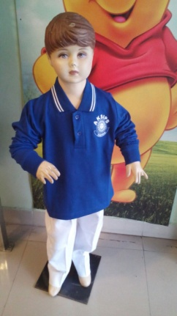
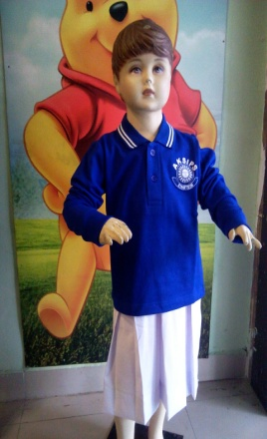
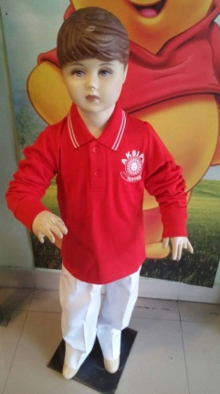
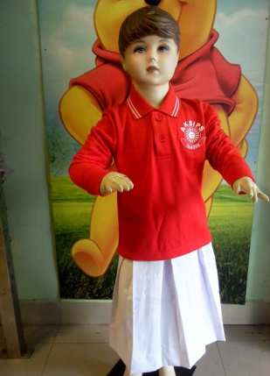
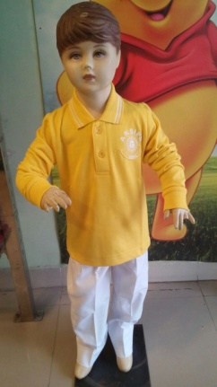
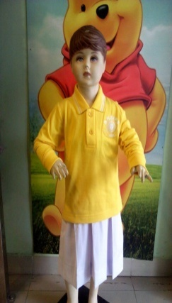
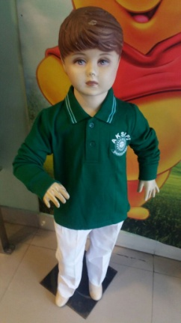
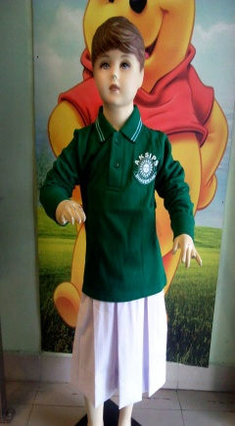
WINTER UNIFORM SUMMER UNIFORM

BOYS & GIRLS EINSTEIN HOUSE SHAKESPEARE HOUSE EINSTEIN HOUSE SHAKESPEARE HOUSE IQBAL HOUSE TAGORE HOUSE
CLASSES PLAYWAY TO K.G BOYS GIRLS BOYS GIRLS BOYS GIRLS
CLASSES I TO XII CLASSES I TO XII CLASSES I TO XII CLASSES I TO XII CLASSES I TO XII CLASSES I TO XII
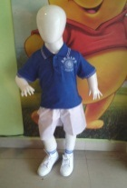
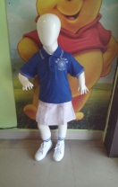
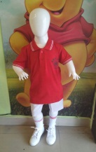
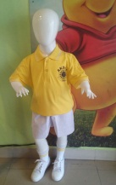
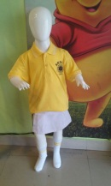

IQBAL HOUSE TAGORE HOUSE EINSTEIN HOUSE SHAKESPEARE HOUSE IQBAL HOUSE TAGORE HOUSE
BOYS GIRLS BOYS GIRLS BOYS GIRLS
CLASSES I TO XII CLASSES I TO XII CLASSES PLAYWAY TO IV CLASSES PLAYWAY TO IV CLASSES PLAYWAY TO IV CLASSES PLAYWAY TO IV

BOYS : Coloured Full sleeves T-Shirt as per the House and White Trousers BOYS : Coloured Half sleeves T-Shirt as per the House and White Shorts & Trousers
GIRLS : Coloured Full sleeves T-Shirt as per the House and White Skirt GIRLS : Coloured Half sleeves T-Shirt as per the House and White Skirt
SCHOOL UNIFORM MAY BE PURCHASED FROM ANY OUTLET

